**CREATE A TABLE FOR BANK AND USE THE ATTRIBUTES AS PER THE REQUIREMENTS TO MERGE THE TWO TABLES AS BANK AND THE TRANSACTION.**

**a)INSERT 5 ROWS IN EACH TABLE AND PERFORM THE CASH WITHDRAW TRANSACTION USING THE CLAUSE CALLED ‘MERGE’.**

**b)PERFORM TCL STATEMENTS USING ATLEAST 4 TRANSACTIONS.**

**i)WITH ONE TABLE**

a) CREATE TABLE BANK1(acc_id INT PRIMARY KEY,acc_name VARCHAR(100),balance DECIMAL(10,2));

INSERT INTO BANK1 VALUES(1,'John',1000.0);

INSERT INTO BANK1 VALUES(2,'Johnson',1500.0);

INSERT INTO BANK1 VALUES(3,'Jane',2000.0);

INSERT INTO BANK1 VALUES(4,'David',2500.0);

INSERT INTO BANK1 VALUES(5,'Smith',3000.0);

SELECT * FROM BANK1;

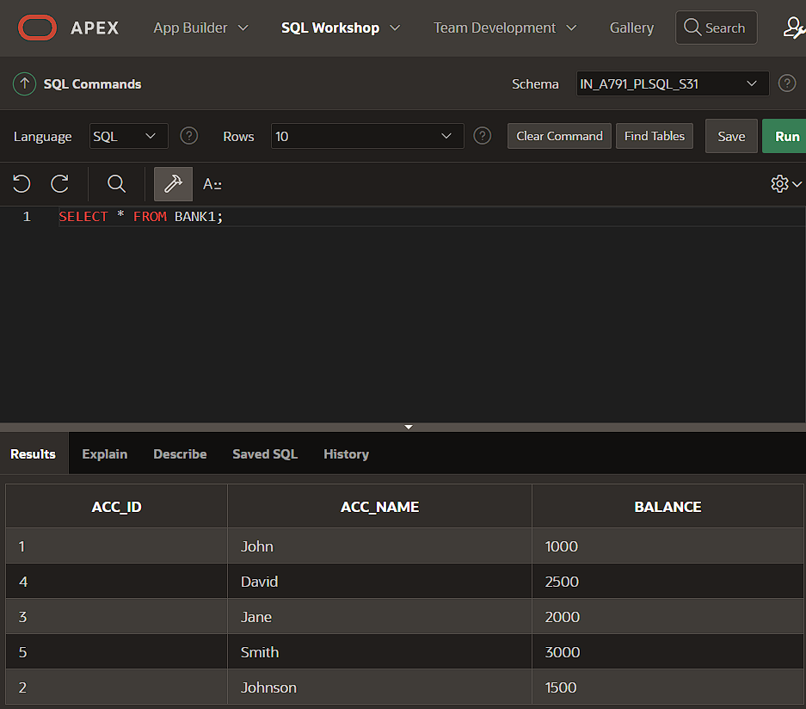

MERGE INTO BANK1 b USING(

SELECT 4 AS acc_id FROM DUAL

)t

ON(b.acc_id=t.acc_id)

WHEN MATCHED THEN

UPDATE SET b.balance=b.balance-100;

SELECT * FROM BANK1;

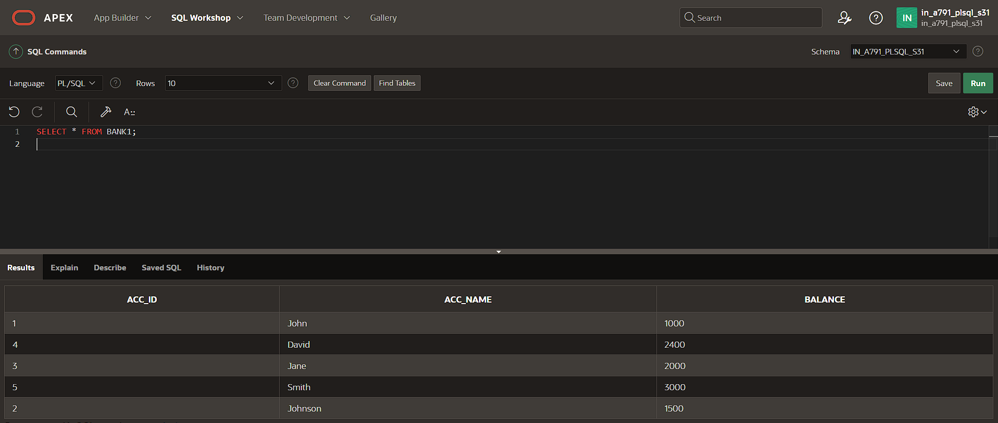

b) BEGIN

UPDATE BANK1 SET balance=balance-100.0 WHERE acc_id=1;

SAVEPOINT S1;

UPDATE BANK1 SET balance=balance-200.0 WHERE acc_id=2;

SAVEPOINT S2;

UPDATE BANK1 SET balance=balance-300.0 WHERE acc_id=3;

SAVEPOINT S3;

UPDATE BANK1 SET balance=balance-400.0 WHERE acc_id=4;

ROLLBACK TO S1;

COMMIT;

END;

/

SELECT *FROM BANK1;

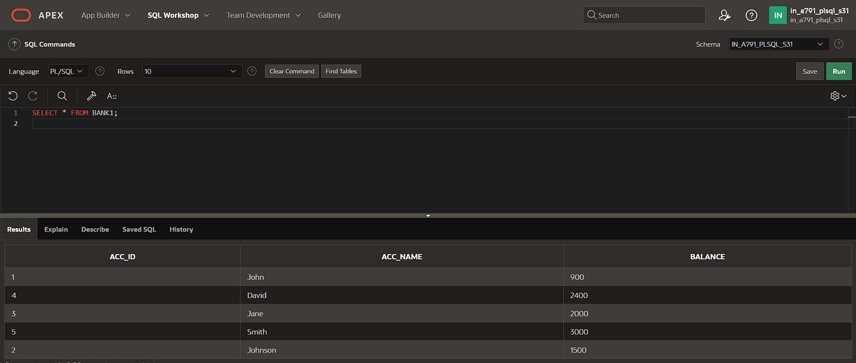

**ii)WITH TWO TABLES**

a)CREATE TABLE BANK(acc_id INT PRIMARY KEY,acc_name VARCHAR(100),balance DECIMAL(10,2));

INSERT INTO BANK VALUES(1,'John',1000.0);

INSERT INTO BANK VALUES(2,'Johnson',1500.0);

INSERT INTO BANK VALUES(3,'Jane',2000.0);

INSERT INTO BANK VALUES(4,'David',2500.0);

INSERT INTO BANK VALUES(5,'Smith',3000.0);

SELECT * FROM BANK;

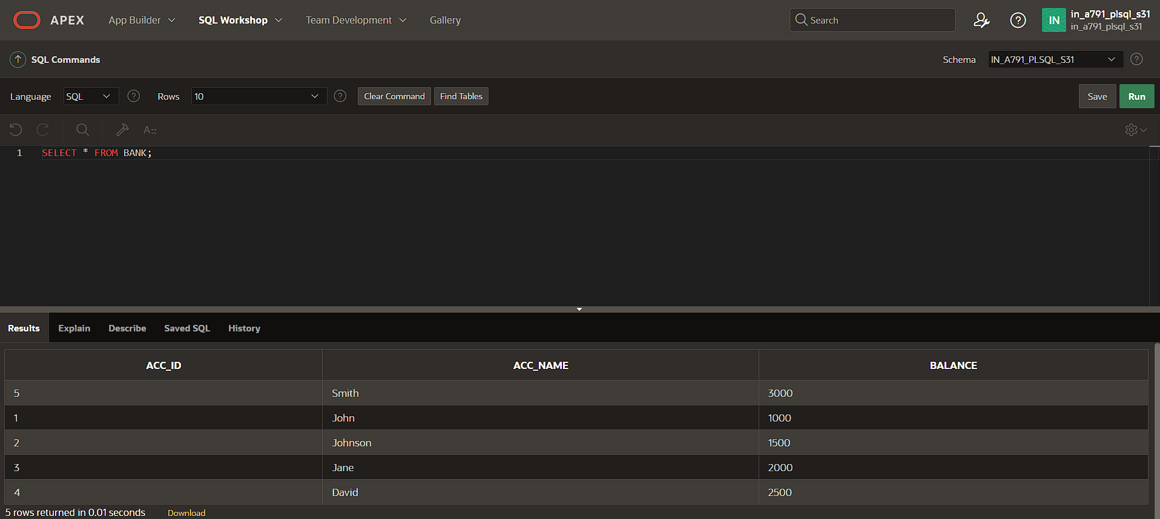

CREATE TABLE TRANSACTION(trans_id INT PRIMARY KEY,acc_id INT,trans_type VARCHAR(50),amount DECIMAL(10, 2),FOREIGN KEY(acc_id) REFERENCES BANK(acc_id));

INSERT INTO TRANSACTION VALUES(101,1,'Deposit',500.0);

INSERT INTO TRANSACTION VALUES (102,2,'Withdrawal',700.0);

INSERT INTO TRANSACTION VALUES (103,3,'Deposit',1500.0);

INSERT INTO TRANSACTION VALUES (104,4,' Withdrawal',1000.0);

INSERT INTO TRANSACTION VALUES (105,5,'Deposit',2500.0);

SELECT * FROM TRANSACTION;

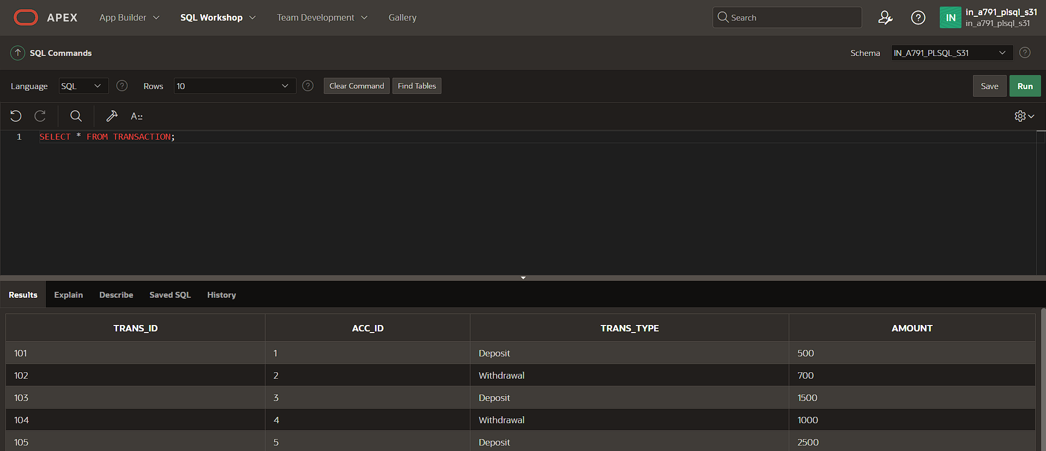

MERGE INTO BANK b USING(

SELECT acc_id,amount

FROM TRANSACTION

WHERE trans_type ='Withdrawal'

)t

ON(b.acc_id=t.acc_id)

WHEN MATCHED THEN

UPDATE SET b.balance=b.balance-t.amount;

SELECT * FROM BANK;

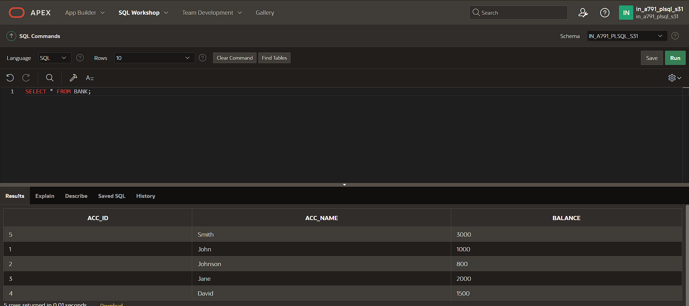

b) BEGIN

UPDATE BANK SET balance=balance-100.0 WHERE acc_id=1;

INSERT INTO TRANSACTION VALUES(106,1,'Withdrawal',100.0);

SAVEPOINT S1;

UPDATE BANK SET balance=balance-200.0 WHERE acc_id=2;

INSERT INTO TRANSACTION VALUES(107,2,'Withdrawal',200.0);

SAVEPOINT S2;

UPDATE BANK SET balance=balance-300.0 WHERE acc_id=3;

INSERT INTO TRANSACTION VALUES(108,3,'Withdrawal',300.0);

SAVEPOINT S3;

UPDATE BANK SET balance=balance-500.0 WHERE acc_id=4;

INSERT INTO TRANSACTION VALUES(109,4,'Withdrawal',400.0);

ROLLBACK TO S2;

COMMIT;

END;

/

SELECT * FROM TRANSACTION;

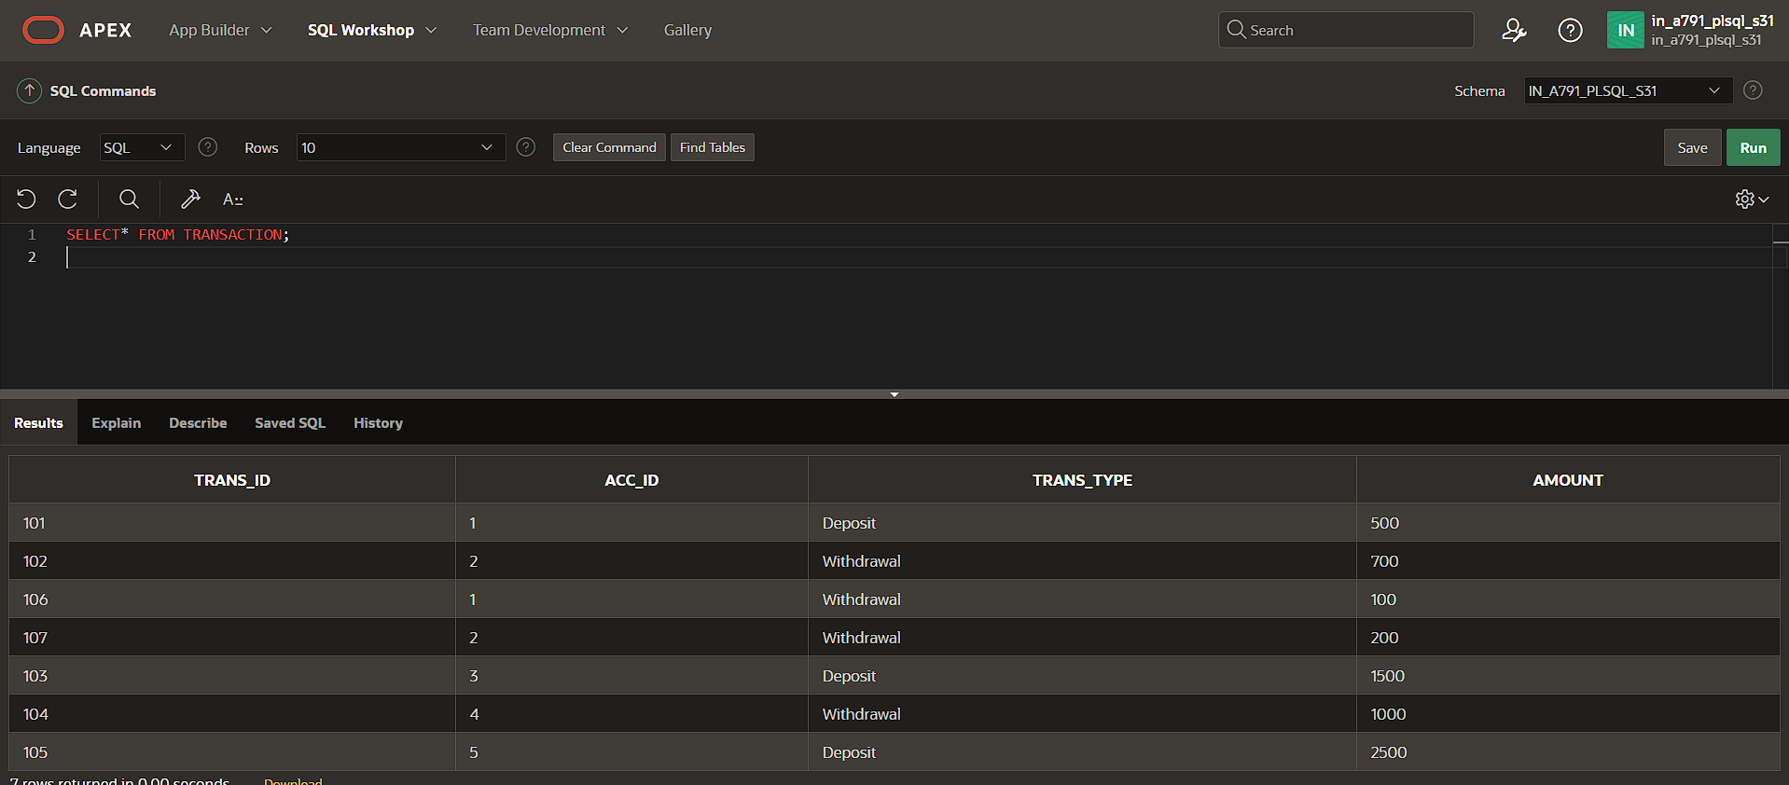

SELECT* FROM BANK;

